الجمهورية اللبنانية
وزارة التربية والتعليم العالي الامتحانات الرسمية لشهادة الامتياز الفني
المديرية العامة للتعليم المهني والتقني لدورة عام 2010 الاولى
===============
الاختصاص والرمز : المعلوماتية الادارية (24004) –الانظمة والشبكات (24101)
المادة : التطوير التطبيقي بالانترنت – البرمجة بلغة انترنت المعدل: (8-6)
المستندات المسموح بها : لا شيء المدة : ساعة ونصف

Treat all the following exercises:

N.B: All the "HTML" files are in the folder: \web
All the "AUDIO" and "VIDEO" files are in the folder: \web\sounds
All the "IMAGES" files are in the folder: \web\photo
All others files are in the folder: \misc

I- Write the appropriate tags to obtain as a result the following page " main.html" while respecting the following conditions:  (4 pts)  - The title has the biggest possible size.  - The title color is white.  - The page background color is green.  - The image name is « picture1.jpg ».  - The border thickness of the picture is two pixels.  - The message « picture1 » should be displayed in the place of the picture in case of error.  - The reload interval of this page is 60 seconds.  - The page author is « html ». | 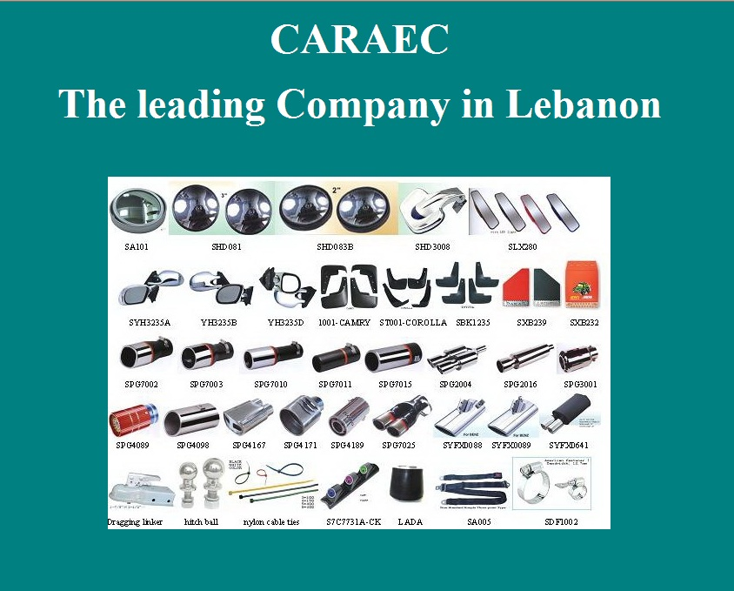
II- Write the appropriate tags to obtain as a result the following page " cat.html" while respecting the following conditions:  (4 pts)  - The image « picture2.jpg » is the background of the first table.  - The background color of the second table is a mixture of blue and green at the lowest tonality.  - The borders colors of both tables are green and red.  - The distance between the text and the table border is 3 pixels in both tables.  - The link « Go Top » points toward the beginning of the page.  - The link « Home » points towards the page « main.html » of exercise I.  - The image name in the second table is « radio.jpg ». | 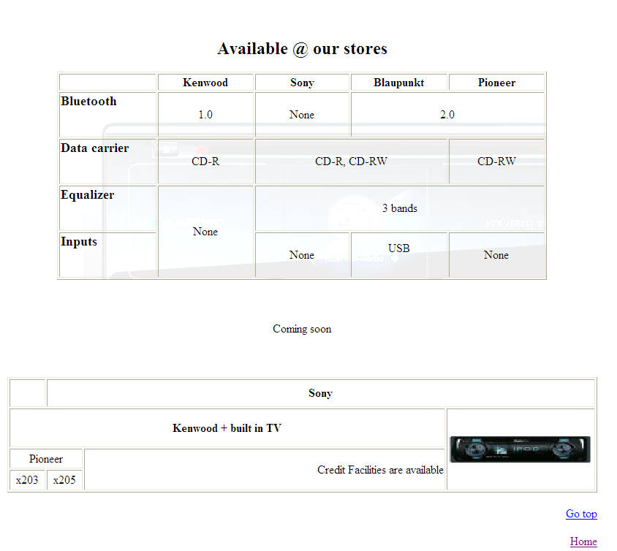

الاختصاص والرمز : المعلوماتية الادارية (24004) –الانظمة والشبكات (24101)
المادة : التطوير التطبيقي بالانترنت – البرمجة بلغة انترنت المعدل: (8-6)
المستندات المسموح بها : لا شيء المدة : ساعة ونصف

 | III- Write the appropriate tags to obtain as a result the following page " online.html" while respecting the following conditions:  (4 pts)  - First Name: Entry field of 30 characters.  - Last Name: Entry field of 30 characters. Visible characters are 15.  - Address: Entry field of 30 characters.  - Phone Number: Choice between 8 values, 01, 02, 03, 04, 05, 06, 07, 08 and 09. The second field is an entry field of 6 characters.  - Marital Status: Choice between 3 values.  - Number Of children: Choice between 4 values 0, 1, 2 and « More than 3 ». By default the value 1 is selected.  - Credit Card Number: Entry filed of 16 characters. You should display stars instead of characters.  - Join our mailing list: An option with an entry field of 50 characters.  - A Submit button that will send the values by email to the following address « online@carec.com »  - A Reset button to restore the original values. | 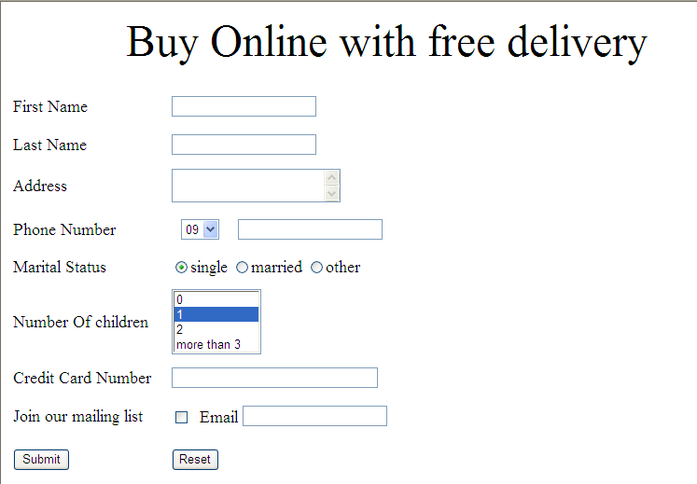

IV- Write the appropriate tags to obtain as a result the following page " indexonline.html" while respecting the following conditions:  (8 pts)  - This page is divided into 4 frames A, B, C and D.  - The first frame "A" displays by default the page «main.html» of exercise I.  - The second frame "B" contains the traveling message « First online car accessories in Lebanon » from left to right 5 times.  The multimedia video « radio » is infinitely played. You should choose the right extension for the file.  - The frame C holds multiple list:  - The link « radio » displays the page « cat.html » of exercise II in the frame A.  - The link « catalogue » download the file « catalogue.doc».  - The link « Buy Online » displays the page « online.html » of exercise III in the frame A.  - The link «Contact Us » send an email towards the following address « contact@caraec.html ».  - The fourth frame D displays a link « Visit google.com » that points towards the address « www.google.com ». This page should be displayed in a new navigator window.  - Create all inexistent needed pages and add the needed tags to preceding pages. | Cadre A:  Width 80 %  Height:70%  Cadre B:  Width : 100 %  Height: 20%  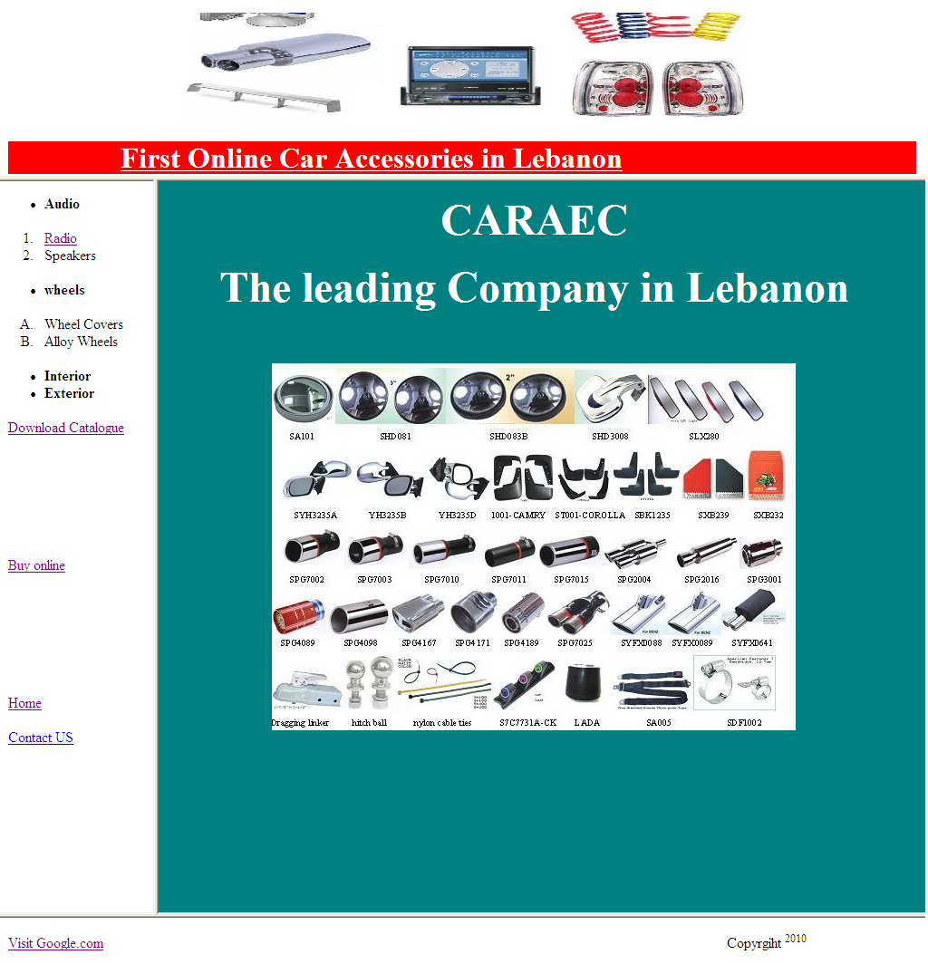  Cadre C:  Width 20 %  Height:80%  Cadre D:  Width 100 %  Height:10%

